Secure Pharmacist
Version 1 - Documentation
The project uses MySQL(Xampp), Python(Visual Studio Code), and Java(Eclipse).
For the project to run, we need to do the following:
- In the Xampp control panel, launch the Apache and MySQL modules.
- Run the Streamlit drugClassification.py file at localhost:8501 in the Visual Studio Code terminal.
- Open Eclipse and run the Login.jsp file at localhost:8080.
MySQL (Database Management System)
For the handling of data for Secure Pharmacist, there are a total of 10 tables. Foreign keys are used to link each table to another.

Table Descriptions
Condition - This table contains information on each medical condition.
Doctor - This table contains information on each doctor user.
Drug - This table stores information on each sold drug.
Feedback - This table holds the information about reviews of prescription drugs offered by doctors.
Patient - This table contains information about each patient user.
Patientcondition - This table keeps track of each medication that patients' doctors have been prescribed.
Purchase - This table stores information on each drug in the form of a blockchain block, with each block representing the purchase of a single drug.
User - This table keeps a user's general information stored.
Usertype - This table stores information about each category of user and their degree of authorization.
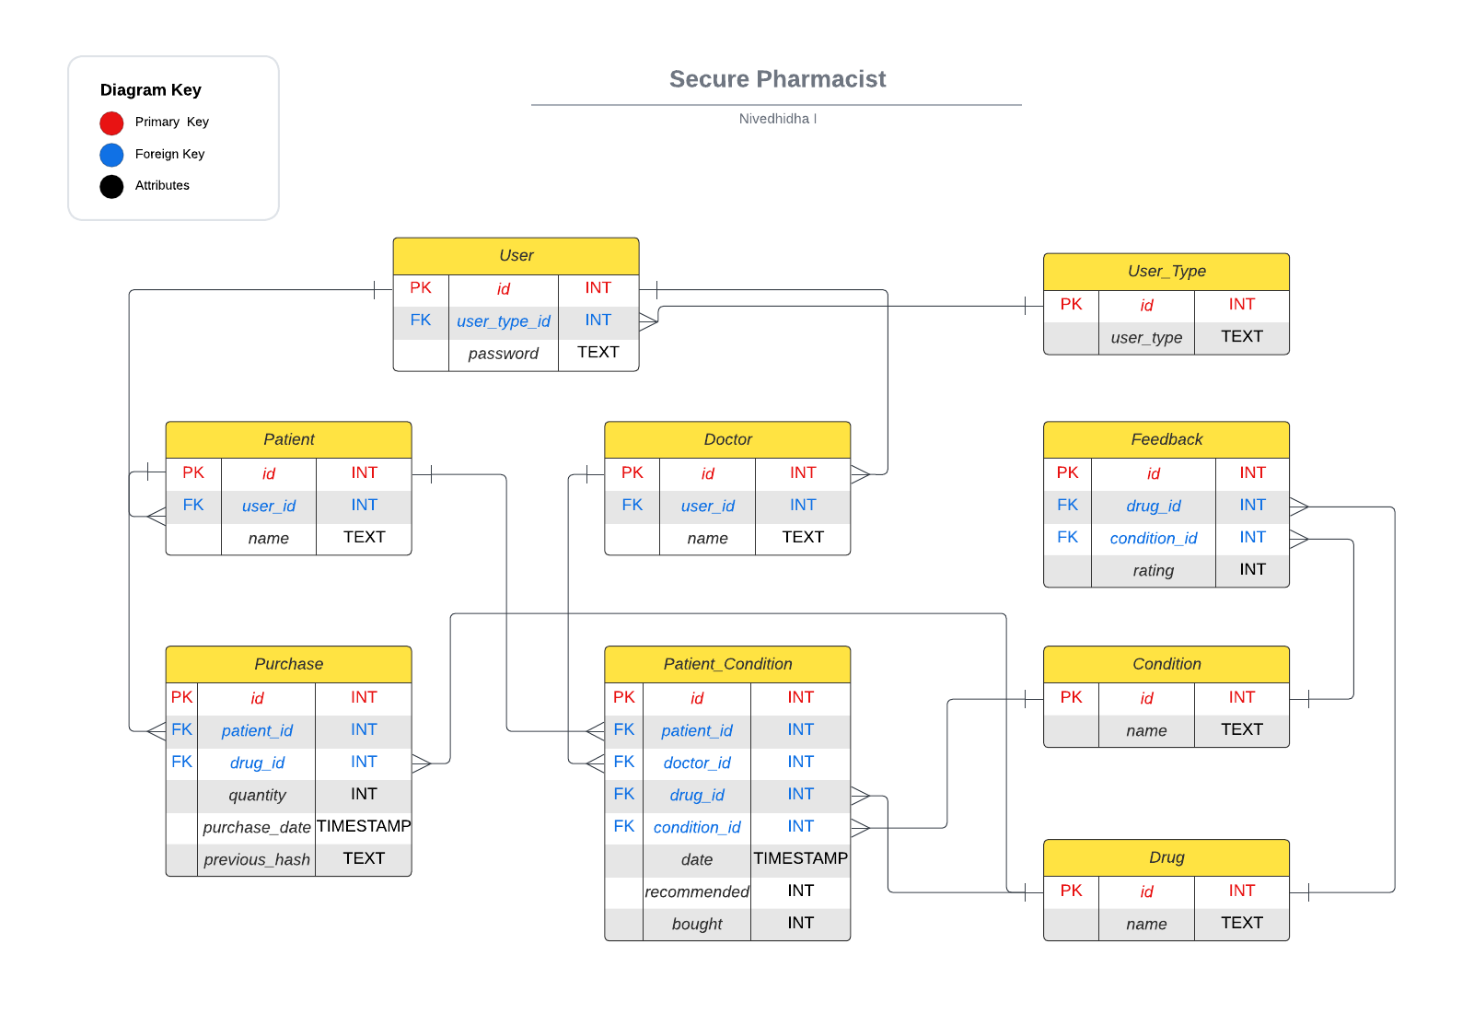
Fig 1. ER Diagram of Database

PYTHON
The Python modules used were Sklearn for machine learning and Streamlit for web development.
Process for Drug Classification:
- Loading of Datasets
  - Load the train dataset's necessary columns as a dataframe.
  - Load the necessary test dataset columns as a dataframe.
  - Create a single dataframe by combining the two dataframe variables.
- Cleaning the Datasets
  - Data verification and removal of inaccurate data
  - Determining whether NA values are present and removing rows
- Munging Process for Dataset
  - Rows with a rating of at least 7 are filtered.
  - Making a new table containing the medicine names, the medical condition, computed average rating, and the data's classification into classes A, B, and C based on average rating.
- Recommendation Models
  - Using the munged dataset, SVC, Rain Forest, and Naive Bayes models were used to categorise the drug into classes A, B, and C.
  - By using the confusion matrix and accuracy_score(), accuracy scores were computed.
- Ensembling Models
  - By using the Hard Voting Ensemble algorithm, the three models mentioned above, were combined into a single model.

Streamlit (Recommendation page):
The website has hyperlinks in the sidebar to the following two pages:
- Model Page
- A medical condition can be selected from the drop-down list that is presented.
- For the selected medical condition, three lists of the most, second-most, and least recommended drugs will be presented.
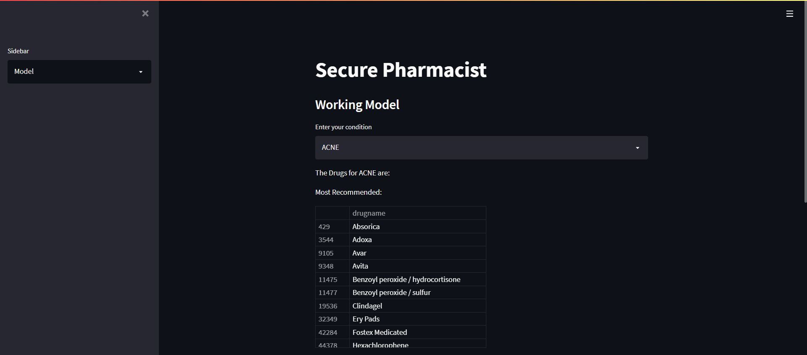
Fig 2. Demo of Model Page (i)
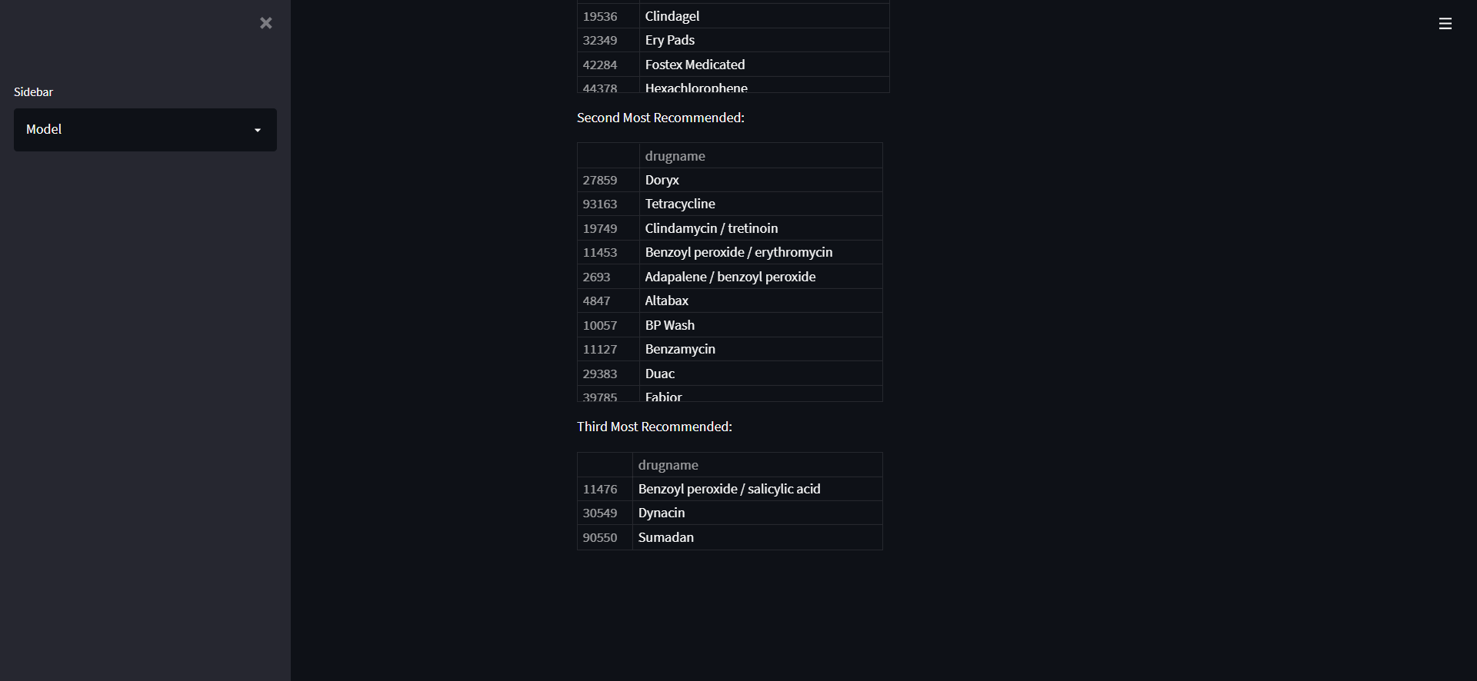
Fig 3. Demo of Model Page (ii)
- Accuracy Page
- Each model, including the ensembled model, has an accuracy score(), confusion matrix, and ROC accuracy score that are provided for reference purposes.
- The accuracy rates are 96.9% for the Naive Bayes model, 91.7% for the Random Forest model, 97.02% for the SVC model, and 97.21% for the Ensembled model.
- From the graphical comparison, it is clear that the ensembled model outperforms the other methods in terms of accuracy, making it a better model overall.

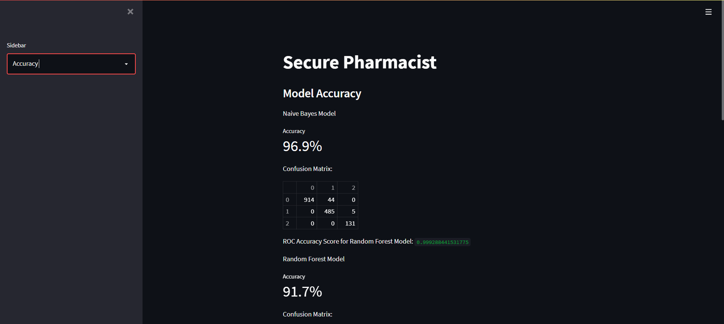
Fig 4. Demo of Accuracy Page (i)
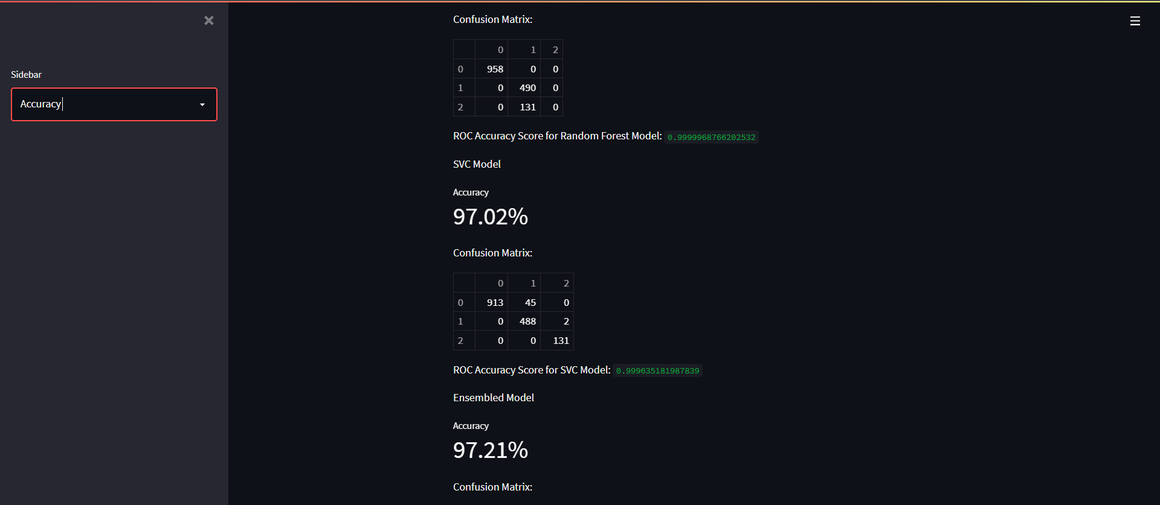
Fig 5. Demo of Accuracy Page (ii)
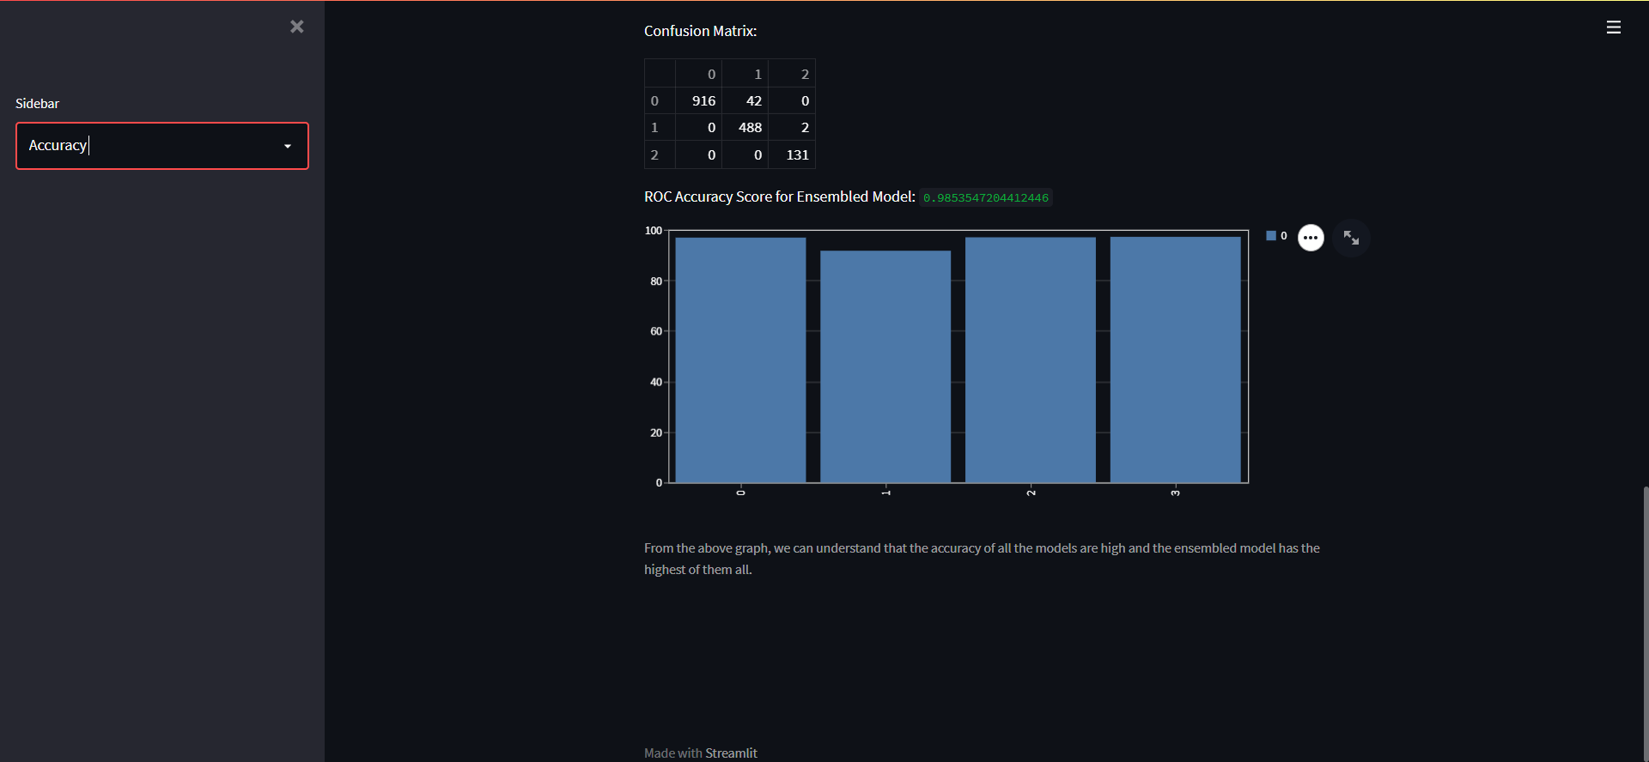
Fig 6. Demo of Accuracy Page (iii)
JAVA
Detailed Layout of the Website:
Domain: http://localhost:8080/Healthcare
Login
Doctor & Patient
Ordering
Patient
Doctor
Tracking
Home
Create
Home
Feedback
View
Recommendation

Fig 7. Site Map of Website

Description:
The motivation behind the development of drug recommendation is to build a web based application considering two entities: doctor and patient. The functionality of this web application includes, authentication of medical records of patients, ordering medicine by patient, doctor’s prescription, medical records of the patient. The core implementation of this web application is to track the order placed by the patients. The tracking of order is based on block chain validation. The transactions in a block contain details such as patient's ID, purchase date, medicine ID, and quantity purchased. Each block represents a transaction and blocks are chained using the hash of the previous block. The block chain is connected to a MySQL database.

All pages—aside from the login page—have header links to the appropriate pages, a logout button that takes you back to the login page, and a link in the logo that takes you to the relevant home page.

Login page - After entering a user ID and password and pressing the login button, this page verifies the information with its database and, if a match is discovered, determines whether the user is a doctor or a patient. They are directed to the patient home page if they are a patient, otherwise to the doctor home page.
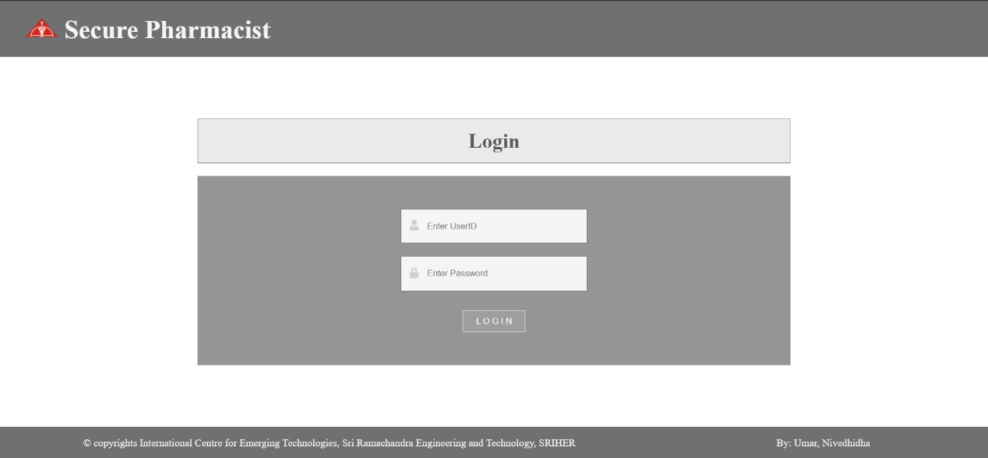
Fig 8. Demo of Login Page

Patient Home page - The page includes a brief introduction of the website to help patients who have logged in understand what can be done there and how to make the most of it.
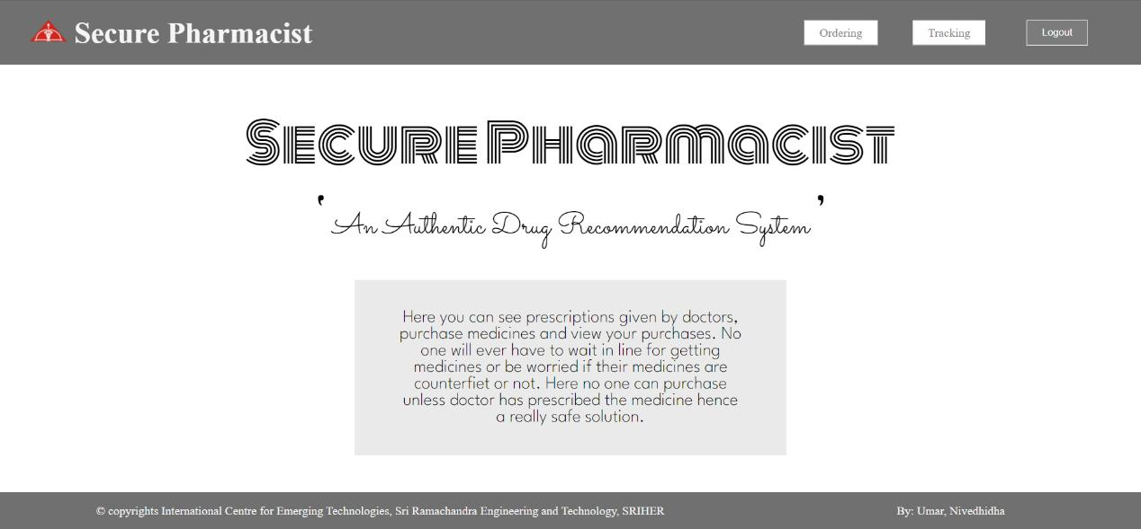
Fig 9. Demo of Patient Home Page

Ordering page -
A digital prescription for the patient, which also stores information on how much medication the patient has already purchased and how much more can be purchased, is somewhat similar to the left side table on this page.
On the right side is a cart that shows the medications the patient can purchase that have been prescribed by the doctor but only if there is at least one more quantity to be purchased.
The cart accepts the quantity of each medicine; the input is a number type and only accepts a number that is between 0 and the quantity of that particular medication that is still left to be purchased.
Each medicine's amount entered is checked when the purchase button is pressed. If the number is not 0, the Transaction class is used to create a transaction with each medicine's data, including the id of the medicine, the purchase time, and the quantity.
The Block class is then used to convert each transaction into a Block. An object of the Block class can store a single transaction object and the previous block's hash value.
For obtaining the previous block's hash value, the previous block is recreated, then hashed using a hash function.
The security of the data is maintained as this is done in preparation for future verification. The new Block will be added to the purchase table.
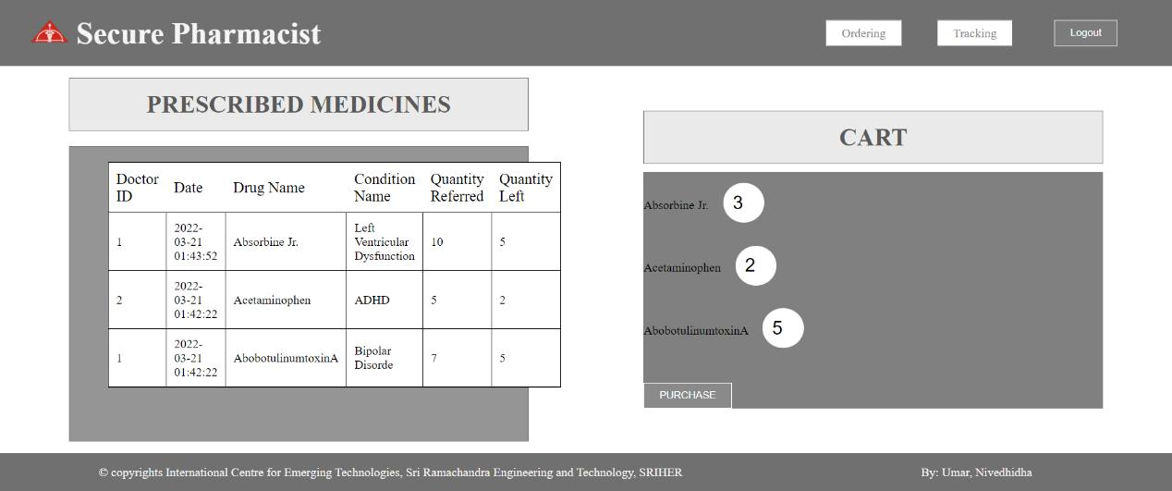
Fig 10. Demo of Ordering Page

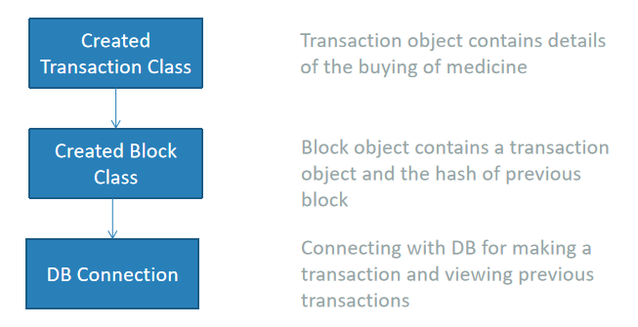
Fig 11. Flow Chart of Blockchain Model

Tracking page - This page lists the specifics of each medication that the relevant patient has purchased, along with the date of purchase. This information is taken in the form of a block from the purchase table.
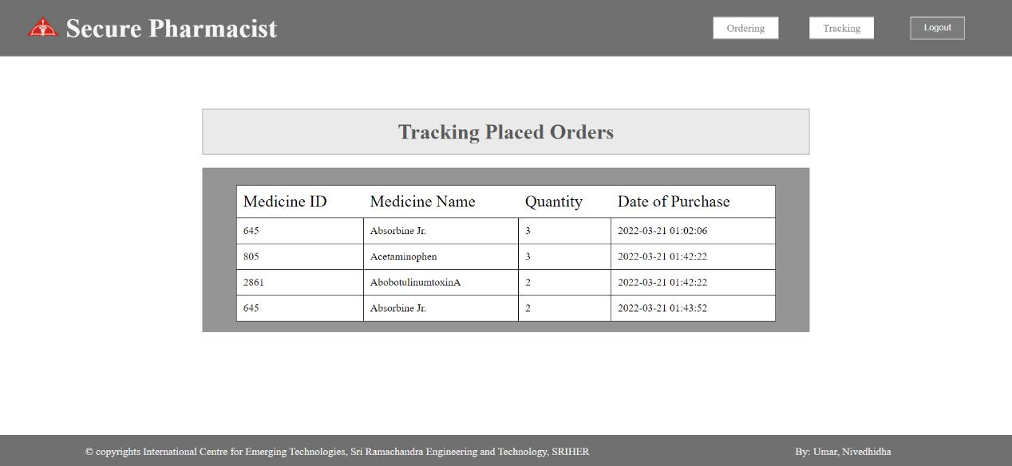
Fig 12. Demo of Tracking Page
Doctor Home page - The page includes a brief introduction of the website to help doctors who have logged in understand what can be done there and how to make the most of it.
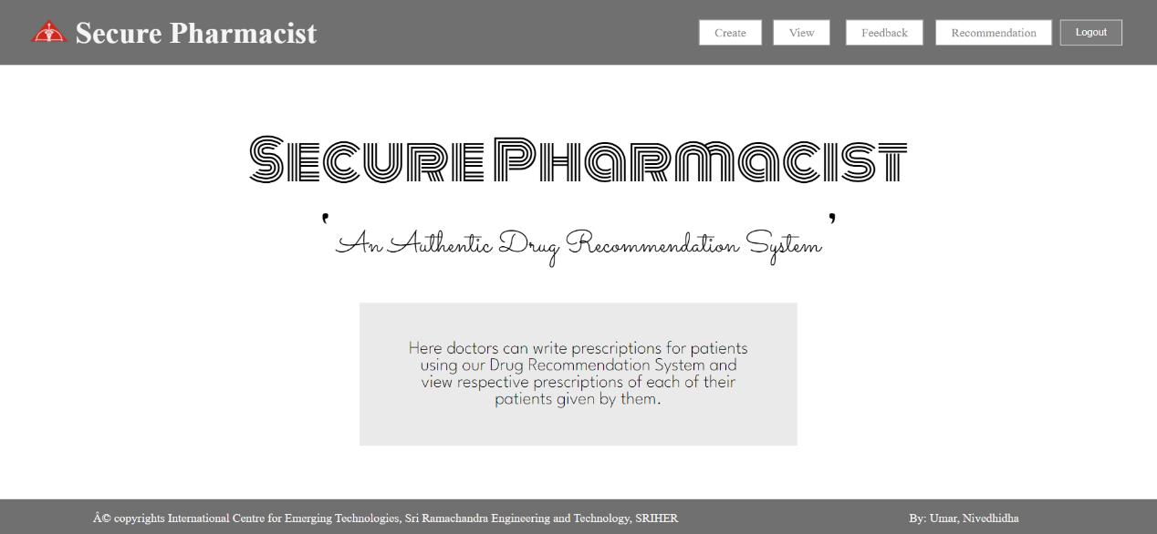
Fig 13. Demo of Doctor Home Page

Create page - This webpage provides a form that may be used to prescribe medications to patients by entering their patient id, the medical condition they are suffering from, the medication they should take, and the recommended dosage. The drug name dropdown in this case is dynamic, meaning that the doctor can only choose from the drugs that are included in classes A and B of the disease that was selected in condition dropdown. They must fill the prescription maker separately for each drug they wish to administer. Patients can view this information, entered by the doctors here, on their order page.
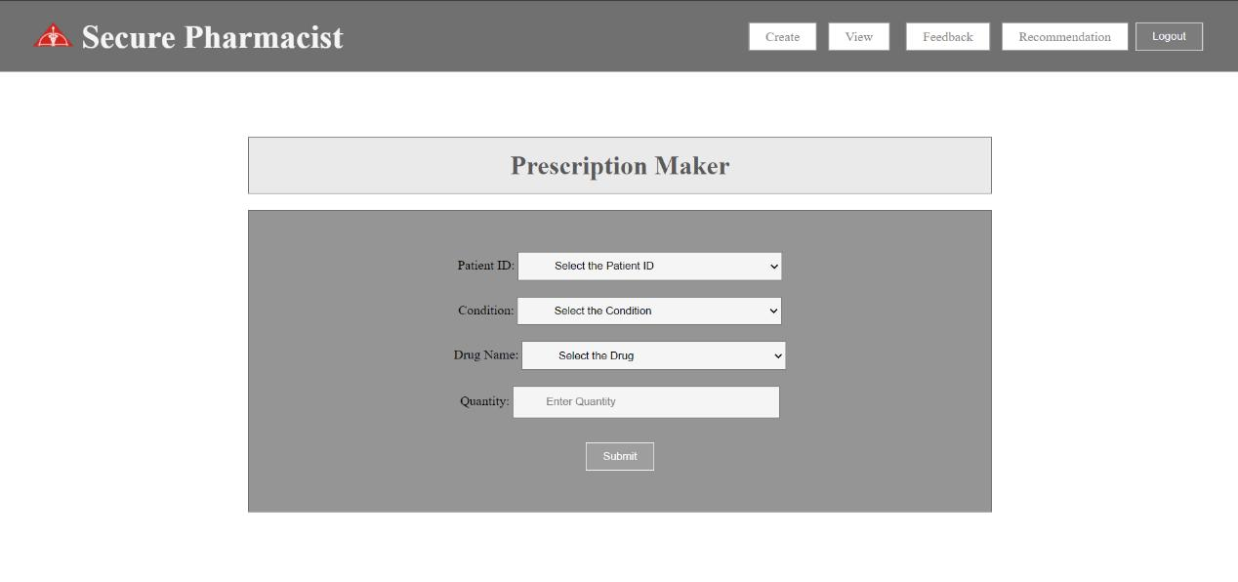
Fig 13. Demo of Create Page
View page - This page was created to enable a doctor learn about any patient's medical history based on the prescriptions prescribed by numerous doctors over the course of time. Additionally, as a part of providing the medical history, there are plans to include information regarding medical tests results. In order to access the correct drugs, the doctor would need to choose the relevant patient's id.
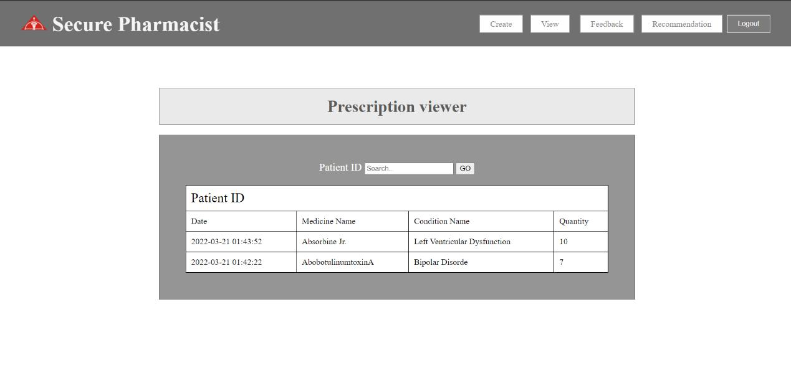
Fig 14. Demo of View Page

Feedback page - Doctors can choose any of the drugs listed on this page and provide a rating. The information from this website is added to a dataset that is then used to categorize the drug into classes A, B, and C.
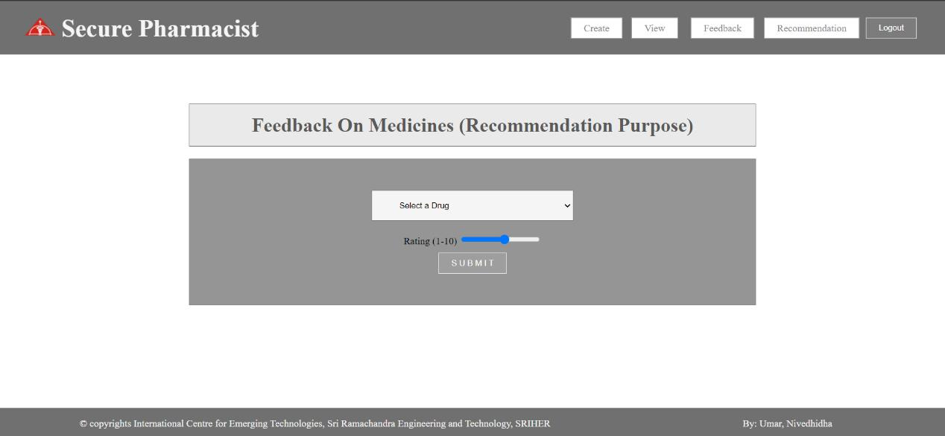
Fig 15. Demo of Feedback Page
Recommendation page - The website has an iframe tag that stores the link to a drugRecommendation.py file that is running locally and compares the various models utilized for this process.
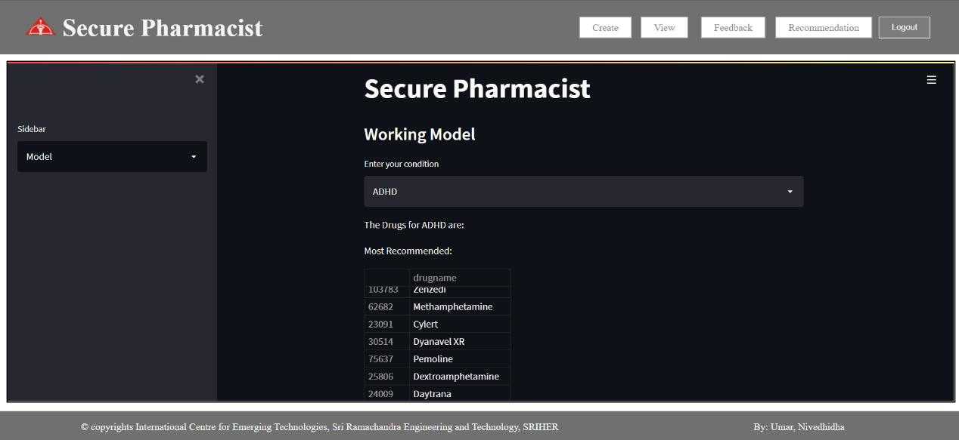
Fig 16. Demo of Recommendation Page

what is the database requirement to include blockchain for secure payments
Version 2 - Improvements (10/12/2022)
Pharmacy
- Make a webpage which can be used by pharmacies where they can write the stock in and make changes to purchase if accepted/rejected/shipped.
- When a medicine is changed to shipped in status of purchase, the stock table should change quantity_left reducing the value as per the quantity being purchased.
- We can either have a single table which takes care of the stocks on the whole without recording when stock entered or exited (like the existing one)
- we can make separate tables for stock in and out along with storing the expiry date so that if a medicine goes beyond expiry date the medicine is not counted for stock left and pharmacy is informed of the remaining drugs which has been expired.
Patient
- Patients should be able to select which city they belong to along with the medicines they want so that they will be provided with the medical shops which are in the cities which contain the medicines they need with the quantity required.
- Patient can be provided with cancel order option if the order hasnt been shipped off yet.
Doctor
- The doctor can be shown filtered with the medicines available in the area so that the doctor doesnt prescribe a medicine which the patient cannot buy

WORKS TO DO:
Completed:-
- Database creation
- Homepage for all three users
- Ordering page for patient (CSS to be improved)
- Tracking page for patient only displaying
- Prescribe page of doctor (SQL statements to be changed)
- View page of doctor (Check and ask for suggestions)
- Orders page of pharmacy (changing of status action to be made - backend)

Points to Remember:-
- User password - 3333
- Doctor password - 2222
- Pharmacy password - 1111
- Hashing technique (using-salt/sugar) hashed this string: “SecurePharmacist::<password>::<userTypeID><userID>”
- Website hashing: https://www.geeksforgeeks.org/sha-256-hash-in-java/

Changes to be made:
- Check login page logged in without password (Done)
- Add security for password by using hashing technique (using-salt/sugar) hashed this string: (Done)
- Providing a page to change password, name and other personal details of users
- Create an admin page to handle the creation of users or signup page
- After logging out the page should refresh when going back automatically and shouldn't contain the details still .. also doctor should not be able to load patient pages by just changing the links
- Work on overall css
- Change in stock should only occur after the store accepts the order
- prescription remaining should be added back if store rejects the order so that patient can order again
- should be able to cancel the order when the status is still not shipped - patient (either separate page for cancellation or an option to be provided in tracking page but code should be written in separate java class not in servlet page) - should the canceled order display 0 as cost or the original cost also should the unavailable order display 0 or original cost?
- For now not taking dis_med table into consideration for prescription by doctor
- Should provide some info about the doctor on the order placing side so that the pharmacy can check and confirm before accepting the order and maybe have a page to show details about the doctor verifying their details without showing their actual personal information/ showing their personal details
- Adding other kinds of information of the patient in the View page in doctor side showing medical history of the patient they want to view but maybe after the patient tells the OTP so that patient info is safe with the doctor even patients can view their own information
- Maybe adding a hospital page which helps to input the data of scan documents of patients or buying equipments from pharmacies directly or a whole sale market which will be connected to both pharmacies and hospitals to get the information
- When the quantity left becomes 0, don't show it in the cart. If the same medicine is given many times, display the medicine only once and the max as the sum.
- Separate page for adding stock details and another for viewing stock details

- In future we can add a confirmation of doctor, and every other person by using some kindof documents which should be submitted and maybe digital signature can be used where only one person can sign and everyone can view (cybersecurity)
- we can add hospital and wholesale market as new entities
- hospitals and pharmacies can buy all medicines from whole sale markets
- hospitals can also get patient entries in patient out patient and submit the documents of tests but cannot view, contain doctor details which doctor belongs to which hospital, hence every doctor should belong to some or the other clinic which should be registered and also contain details regarding what category they belong to pediatrics or psychology
- everytime a doctor needs to see patient details he/she must get an OTP from patient phone or email and if refreshed should not be able to see until got again hence sensitive documents safe
- login page contains hashing technique hence safe
- revisiting already visited pages still contains data unless refreshed hence not safe (need an idea for this)
- can we encrypt and store the remaining data too? If okay which type of data encryption (end to end encryption) also what data should be encrypted and what not
- is the database okay or what else do you think should be added?
- patient can maybe be provided with a specific prescription like layout if they choose the prescription of that date or something a small info shown and maybe open it and show the larger view with separate page
- doctor prescribe page can be made in a different way maybe for providing all the medicines at once instead of choosing the medicine one by one and maybe only show medicines which match the disease
- pharmacy should have a certain way to confirm that the doctor indeed is a good one and we can accept this order nu and if order is accepted there should be some kindof notification system
- patient can cancel the order till the status becomes order shipped (since this is shared data should see to that patient doesn't by mistake cancel the order while the pharmacy is changing the status to shipped or vice versa)
- decide if it is a centralised or decentralised one so that we know if we need an admin page which takes care of the varification while a person registers and account only created when verified else we need to make AIML part to verify the document given but there is a risk to people forging document hence should be a really reliable one for decentralisation to work
- should most likely be centralized if we are working with storing of documents right because it should be stored and cannot be shared with everyone and it's really sensitive data (not sure)
- if wholesale part is done then we have to make a webpage where pharmacy can buy from whole sale and if that is done then maybe the buying and selling of all drugs can be stored in a single place instead of separate place for wholesale to hospital and wholesale to pharmacy and pharmacy to hospital and pharmacy to patient
- maybe medical bills from hospitals to patients can also be stored in the database like amount per day for each type of room and what amount for each test so that it can become same price throughout and also can be calculated to be provided to the inpatient while they are leaving the hospital being discharged when a doctor is certifying that the patient can be discharged
- hence details of number of beds available and other stocks should be present in database and which patient is requiring what resource at what period of time if it is reusable like rooms then should be stored as occupied by this person then free and if not reusable like oxygen cylinder then should be put as used by this person and should be reduced by count
- maybe can make hospitals or pharmacies to have a minimum amount of every resource which is not reusable and be able to set a notification if the amount is less so that they can try to contact a wholesale market to get refill
- everyone be connected by location hence if i type my location and the type of doctor i want to visit i will be shown with results to nearest of that requirement

ER Diagram
ID
userID
name
cityID
pharmacy
ID
patientID
doctorID
diseaseID
medicineID
date
quantity
remaining
prescription
ID
status
status
ID
userID
name

doctor
ID
Name
disease
ID
patientID
date
pharmacyID
medicineID
quantity
cost
statusID
purchase
ID
City
city
ID
userTypeID
password
user
ID
userID
Name
patient
ID
pharmacyID
medicineID
quantity_left
stock
ID
userType
usertype
ID
name
cost
medicine
IS A
IS A
IS OF
IS FROM
IS A
HAS
OF
OF
FOR
OF
FOR
WRITES
HAS
FROM
DOES
Sitemap

Login
Patient Home Page
Doctor Home Page
Pharmacy Home Page

Ordering Page

Tracking Page
Prescription
Ordering Section
Medicines Ordered
Cancellation option

Prescribe Page
Form for Prescription Making

View Page
Prescription of Selected Patient

Orders Page
Orders Displayed

Stock Page
Stock Details
Change Status
Add Stock

